Design of Embedded and Intelligent Systems

Lab - Sensor Fusion

Submitted by:

Martin Koottiparampil Varghese

Problem 1:

The Kalman filtered value is plotted for the distance calculated

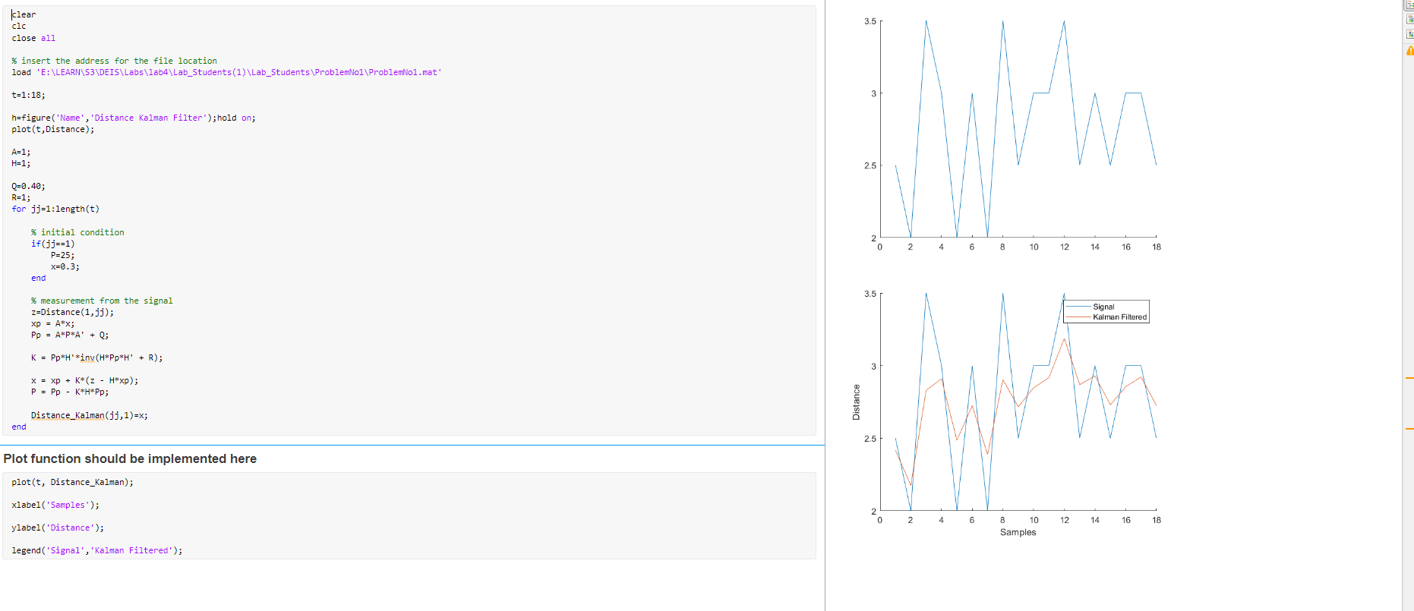

Problem 2:

The Q and R values has been identified and Kalman filter to identify the signal changes over time:

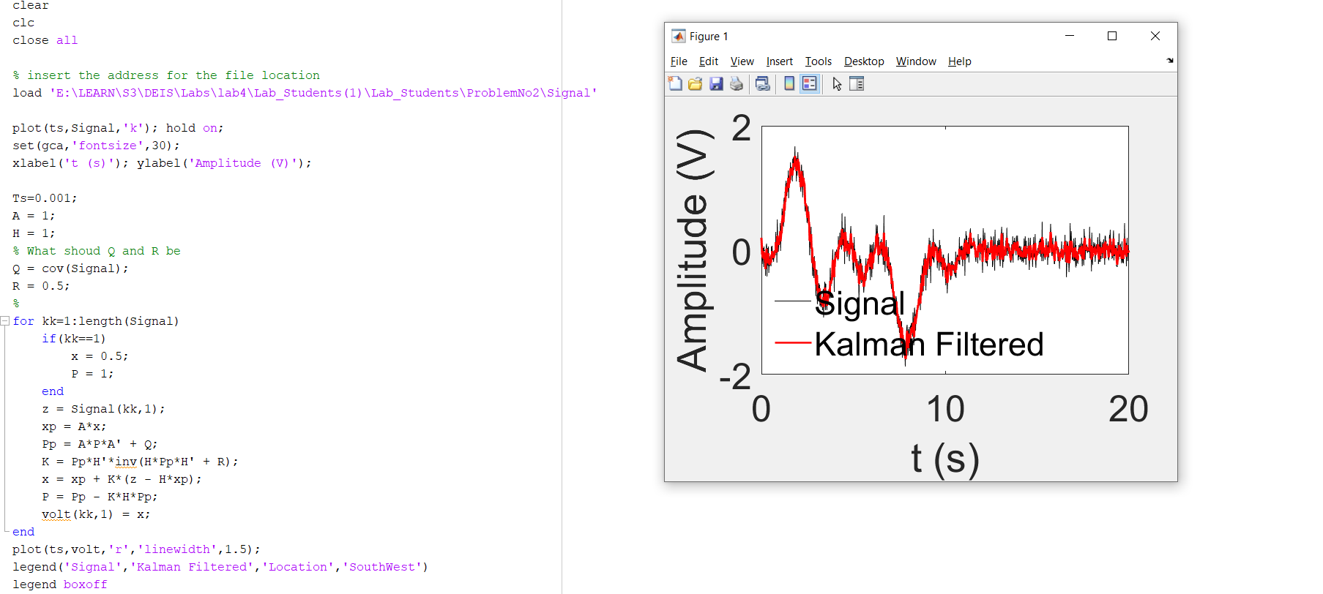

Problem 3:

The value for Q and R has been identified:

Q = 0.001\*eye(4);

R = 50\*eye(4);

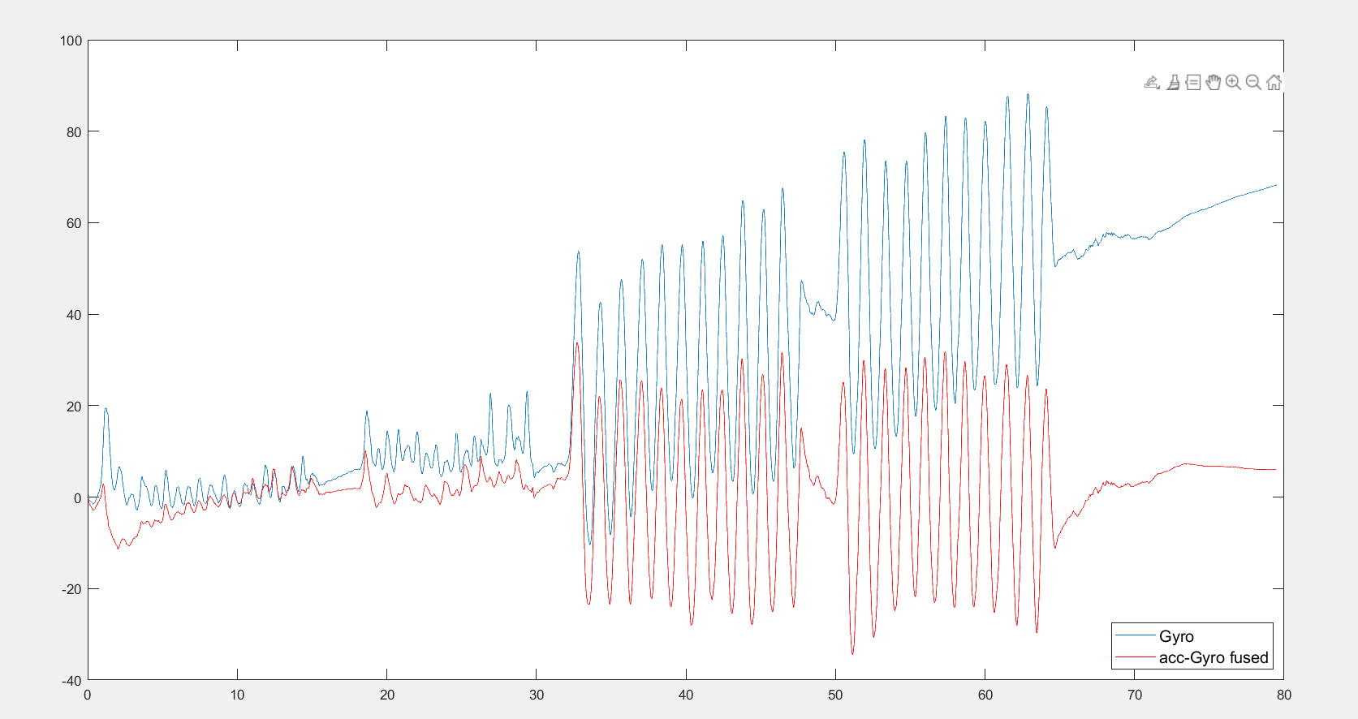

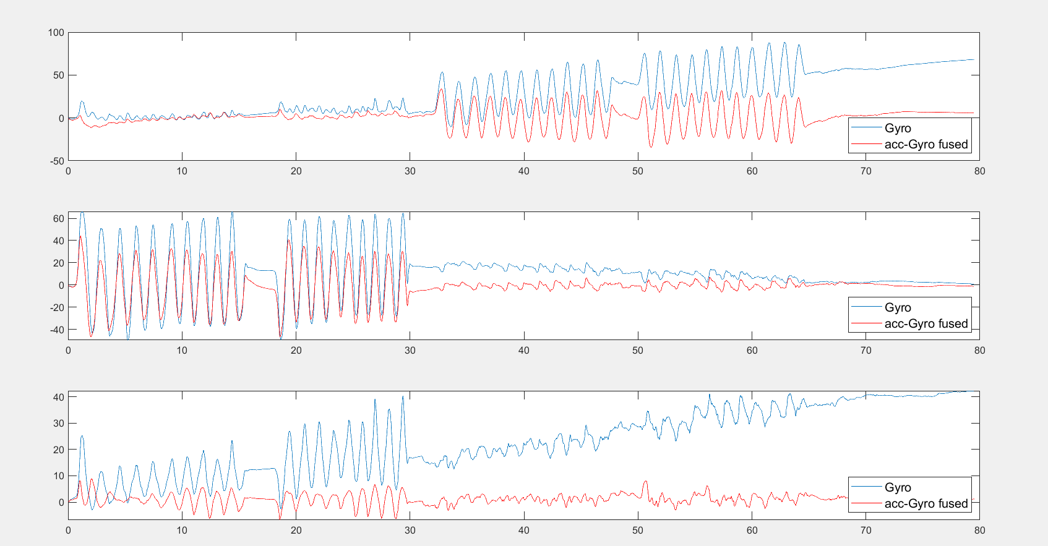

Problem 4: